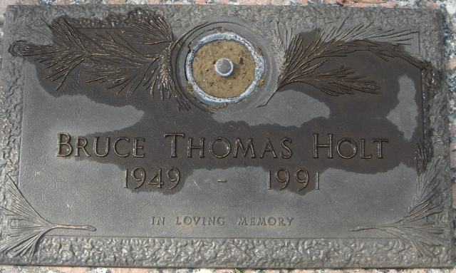
Tallahassee Democrat Monday May 20, 1991
B. Thomas Holt, 41 of Tallahassee died Saturday, May 18, 1991, at Tallahassee Memorial Regional Medical Center. No services are planned. The family will receive friends from 5 to 7 p.m. at Julie Holt residence, 1211 Brookwood Drive. Memorial contributions may be made to the Diabetes Center at Tallahassee Memorial Regional Medical Center, 1221 Hodges Drive, Tallahassee, Florida 32308
A native of Raleigh, N.C. he had lived in Tallahassee since 1969. He was a program administrator with the State Department of Health and Rehabilitative Services.
Survivors include his wife, Julie Holt, of Tallahassee; his mother, Gloria Fletcher Holt, of Jacksonville; a brother, J.B. Holt, Jr., of Orange Park and his paternal grandmother, Lucille Holt, of Raleigh, N.C.
(Culley’s Meadow Wood Riggins Road Chapel

