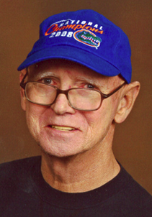
Funeral services for Leo A. Mehrtens, Sr. of Jacksonville, FL will be held 11 a.m., Monday, December 7, 2009 at Old Plank Road Baptist Church (8964 Old Plank Road) with Pastor Larry McGinley officiating.

The interment will immediately follow in Riverside Memorial Park. The family will receive friends from 2-4 p.m. on Sunday, December 6, 2009 in the chapel of Prestwood Funeral Home.

Mr. Mehrtens was born on September 8, 1948 in Jacksonville, FL, son of the late Joseph Mehrtens, Jr. and the former Edith Mathis. Leo was retired from the Duval County School Board after 37 years of service.

He passed away into the arms of his heavenly father on December 2, 2009 following a lengthy illness.

In addition to his wife of 40 years, Lillie Mehrtens, survivors include: two sons, Anthony and Leo Mehrtens, Jr.; grandson, Kevin Mehrtens; granddaughter, Gabrielle Meyers; three brothers, Joseph Mehrtens, III, Richard (Yvonne) Mehrtens and Charles (Vickie) Mehrtens; sister, Rita; life-long friends, Phyllis Quinn, Arline and Ed Snyder; numerous aunts, uncles, nieces and nephews.

In addition to his parents, he was preceded in death by brother, Michael A. Mehrtens; nephew, Tim Hardin; and niece, Teresa Johnson.

