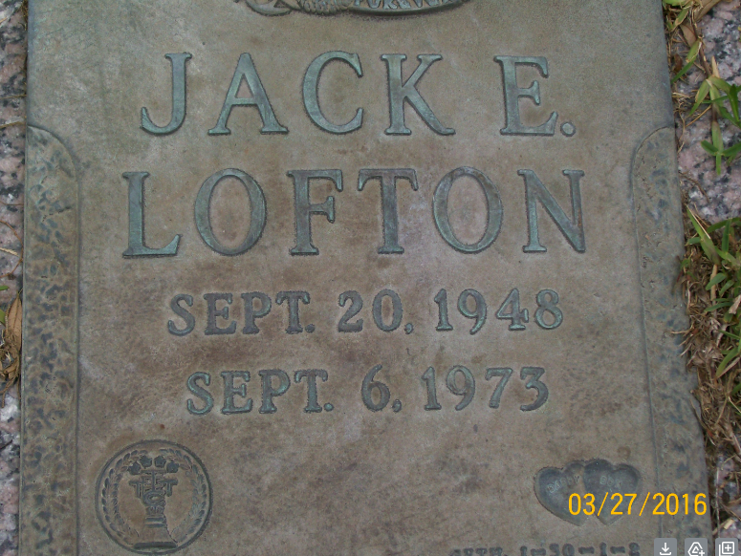

BIRTH
20 Sep 1948
DEATH
6 Sep 1973 (aged 24)
Jacksonville, Duval County, Florida, USA
BURIAL
Restlawn Memorial Park
Jacksonville, Duval County, Florida, USA
No obituary

