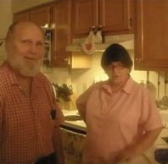

George Howell Nall Sr.

Obituary published on Legacy.com by Peeples Family Funeral Homes on Aug. 21, 2022. [Family did not supply any information for an obituary.]

